Title
Name Surname

Conference paper October 2023
STRC 2024 conference paper
Title
Name Surname
IVT ETH Zurich
Stefano-Franscini-Platz 5, 8093 Zurich, Switzerland

Phone: +41- XX XXX XX XX
Fax: +41- XX XXX XX XX
E-Mail: email@ethz.ch
October 2023
Abstract
Text

Keywords
Keyword 1; Keyword 2; Keyword 3; Keyword 4; Keyword 5; Keyword 6; Keyword 7; Keyword 8
Preferred citation style
Surname, N. (2023) Title, presented at the 23rd Swiss Transport Research Conference (STRC 2023), Ascone, May 2023.
Table of contents
1 Heading 4
1.1 Subheading 4
1.2 Subheading 4
2 Reference list 7
3 Glossary 8
A Appendix Heading 9
A.1 Appendix Subheading 9

List of tables
Table 1: Label 5
Table 2: Label 6
List of figures
Figure 1: Label 7

Heading
Paragraph
Table 1: Label
Heading | Heading | Heading | Heading | Heading
Table content | Table content | Table content | Table content | Table content
Source or notes.

Subheading
Paragraph

Subsubheading
Paragraph

Subheading
- list item
- list item

Table 2: Label
Table header | Table header
 | Sub header | Sub header | Sub header | Sub header | Sub header | Sub header | Sub header
Table content | Content | Content | Content | Content | Content | Content | Content
Source and or notes.

Figure 1: Label
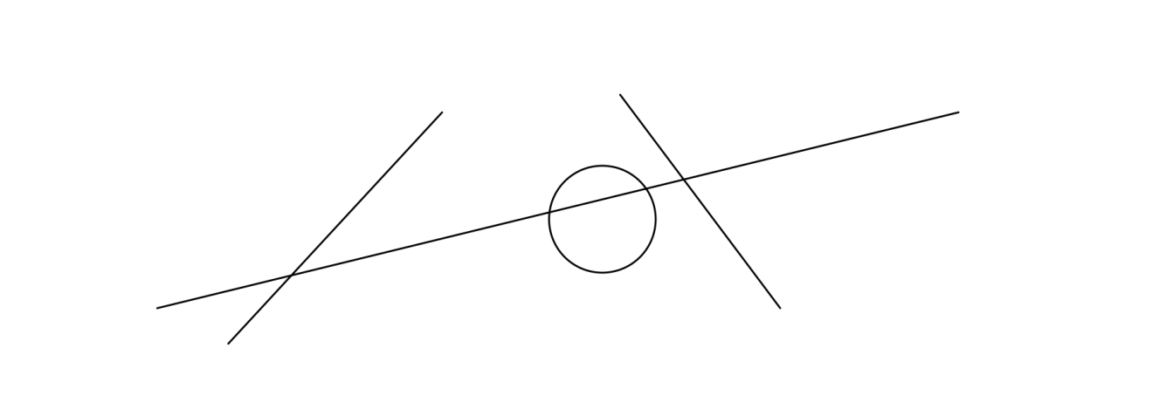

Reference list
Arthur, P. and R. Passini (1992) Wayfinding: People, Signs and Architecture, McGraw Hill, New York.
Backhaus, N. and M. Steinemann (2002) Leitfaden für wissenschaftl. Arbeiten, Schriftenreihe Anthropogeographie, Geographisches Institut, Zurich University UZH, Zurich.
Chapman, M and C. Wykes (1996) Plain Figures, HMSO, London.
Cleveland, W.S. (1994) The Elements of Graphing Data, Hobart Press, Summit.
Dudenredaktion (Hrsg.) (2014) Duden: Die deutsche Rechtschreibung, Dudenverlag, Mannheim.
ETHZ CC (2016) Corporate design, https://www.ethz.ch/services/en/service/communication/corporate-design.html, ETH Zurich Corporate Communications, Zurich, May 2016.
Gowers, E. (1986) The Complete Plain Words, revised by S. Greenbaum and J. Whitcut, HMSO, London.
RSETHZ (2004a) Procedure to address allegations of research misconduct at the ETH Zurich (RSETHZ 415), Rechtsdienst ETH Zurich, Zurich.
RSETHZ (2004b) Disciplinary code of the Swiss Federal Institute of Technology Zurich (RSETHZ 361.1), Rechtsdienst ETH Zurich, Zurich.
RSETHZ (2007) Guidelines for Research Integrity and Good Scientific Practice at the ETH Zurich (RSETHZ 414), Rechtsdienst ETH Zurich, Zurich.
Schweizerische Bundeskanzlei (1996) Leitfaden zur sprachlichen Gleichbehandlung, EDMZ, Bern.
Schweizerische Bundeskanzlei (1998) Leitfaden zur Neuregelung der deutschen Rechtschreibung, EDMZ, Bern.
Tufte, E. (1983) The Visual Display of Quantitative Information, Graphics Press, Cheshire.
Wilkinson, L. (1999) The Grammar of Graphics, Springer, Heidelberg.

Glossary
Text

Appendix Heading

Appendix Subheading

Appendix Subsubheading

Footnote.

